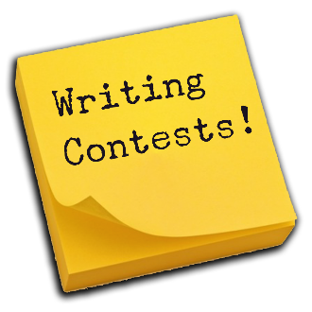
Writing Contest for De Anza District
Entries due to De Anza Chairman by
Wednesday, February 8, 2023
Rules For Writing Contest
- Authors must be dues-paying members of an active GFWC Club (except for Youth Categories).
- Authors must be amateurs (earnings from writing may not exceed $500 annually).
- Entries must be written between January 1, 2022 and December 31, 2022.
- Entries may not have been published prior to the competition and must be the original works by the author.
- A signed GFWC Creative Arts Waiver must be included with each submission (additional forms required for youth entries.
- There are two categories:
  - Short stories limited to 2,000 words and
  - Poetry of any style with a minimum length of 8 lines and a maximum of 50 lines.
- One entry per member per category.
- Entries must be
  - Typed, double-spaced, printed on one side only on 8.5” x 11” paper
  - Have minimum margin of one inch on all four sides.
- Entries must have the following on the top-fight hand corner of each page:
  - Author’s name, email address, mailing address and phone number.
  - Club Name, District, Area and State of the Sponsoring Club.
  - Category.
  - Title of Work.
- Manuscripts Will Not Be Returned

Youth Categories
- While CFWC will not be judging this category at the state level, CFWC will submit District first place student writing entries to GFWC. Same rules as above apply.
- For minors under the age of 18, a signed minor’s consent form and release form and a minor’s publicity release form must be included with each entry, in addition to the Creative Arts Waiver.
- For youth, the categories are:
  - Category 1: Kindergarten, First and Second Grade
  - Category 2: Third, Fourth, and Fifth Grade
  - Category 3: Sixth, Seventh, and Eighth Grade
  - Category 4: Ninth, Tenth, Eleventh, and Twelfth Grade
No later than Wednesday, February 8, 2023, send your club winners by mail or email to:
Kay Masonbrink, De Anza District Writing Chairman
7746 Dutra Drive, Hemet, CA 92545
kmasonbrink@roadrunner.com

